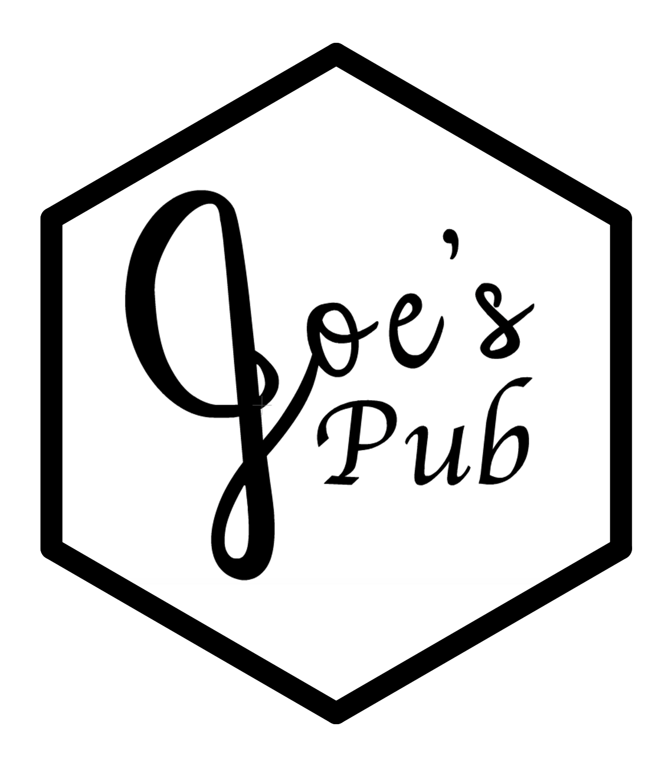

Follow us @chemistry.cocktails Instagram Symbol Logo - Free image on Pixabay

Digital Menu  


# Introduction

We have a wide variety of liquors, liqueurs, and mixers, and can make an extensive array of drinks. We support people ordering their own favorite drinks, or bringing in new recipes from elsewhere, but if you need some inspiration, here are a few drink suggestions.

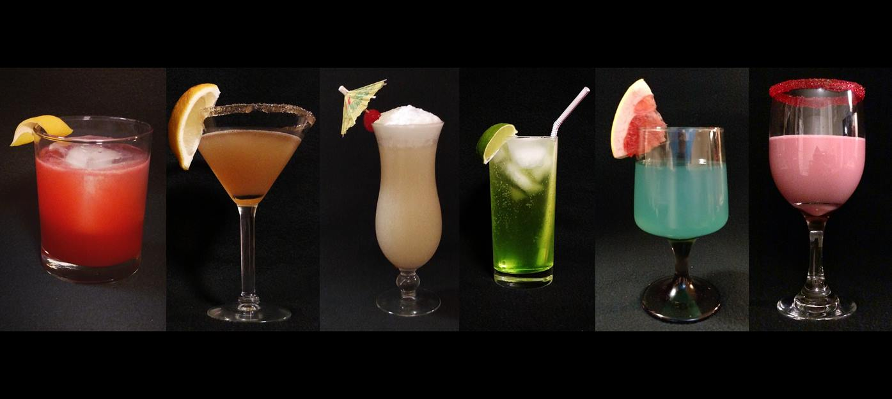

## Our Story

Joe’s Pub started with a boy fascinated by the prospect of mixology. So many liquors, liqueurs, and mixers. So many combinations, ratios, and methods. So many glimmering, gleaming, glinting glasses. Scooped up in the romanticism, what was once a simple hobby, evolved into an outright obsession. With more bottles of alcohol than he had friends, our hero decided to take the knowledge he had learned and the skills he had accrued and present it all to the masses. He was no longer the starry-eyed dreaming boy who began this journey, now he was a man; more than that, he was a bartender.

Eventually, life took Joe on a harrowing adventure across the US and across the world. Joe’s Pub has proudly served cocktails in Rochester, NY; Binghamton, NY; Aarhus, Denmark; and Wilmington, DE, all the while spreading smiles, enjoyment, and quality entertainment.

Above all, we promote an atmosphere of fun and jovial merriment where everyone knows your name and everyone feels at home. Libations are great in their own right, but a community to enjoy them together, built on mutual respect and interest, can’t be beaten.

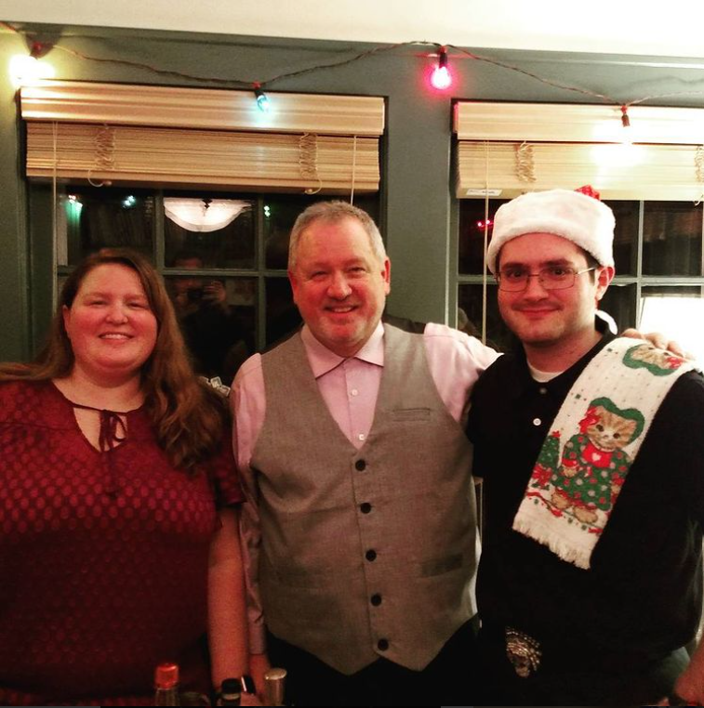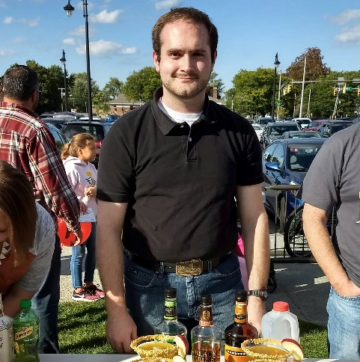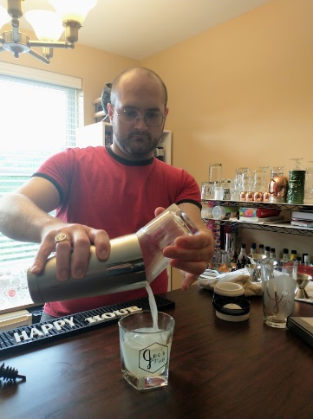

Contents

Introduction 2

Our Story 2

Rules 4

About Our Prices 4

Classic Cocktails 5

Pirated Cocktails 6

Original Cocktails 7

Premium Cocktails 8

Shots 9

Party Shots 9

The Three Musketeers Series 9

For the Sweet Tooth 9

Virgin Cocktails 10

Suggested Cocktails 11

Make Your Own Adventure 12

Hard Liquor 12

Liqueur 12

Mixers 12

Bitters 12

# Rules

* Joe’s Pub is a place where people can gather and have fun, if anything threatens that, it will be removed.
* We work on the honor system. We do not check IDs, but expect that all of our patrons are honest about their legal age.
* There is no last call, but everybody must be gone or going by 12:20 AM (local time)
* We do not condone inebriated driving. Accommodations may be provided at our sister establishment—Joe’s Lounge—for anyone who seems incapable of operating a motor vehicle.
* The bartender’s decision is always final

## About Our Prices

We charge enough to breakeven. Not looking to turn a profit, not looking to rip anyone off, we just want some compensation for what we use.

Discounts, coupons, and special tastings are available, but granted at the bartender’s discretion. Chores, tasks, and odd jobs can be used for coupons or credits.

No compensation is required if your legal surname is, or may become, “Izzo”.

Payment may be made in cash, *via* Venmo to @emubob59, or PayPal to jaizzo92@gmail.com.

If you don’t have means to pay readily available, a tab can be started and paid off at a later date, but this tab cannot exceed 10 USD or 65 DKK.

Money can be pre-paid and recorded by the bartender, but refunds are not available.

First visit is free.

# Classic Cocktails

These are the cocktails that you can order in most any bar. They range from the simple to the complex. Most are well-publicized in the media and at bars. All of them are classics in their own right.

**Cosmopolitan** *Vodka, triple sec, lime juice, cranberry juice*

**Gin & Tonic** *Gin, tonic water*

**Grasshopper** *Vanilla vodka, green crème de menthe, white crème de cocoa, half-and-half*

**Mai Tai** *White and dark rum, triple sec, orgeat syrup, lime juice, lemon juice*

**Margarita** *Tequila, Cointreau®, lime juice, salted rim*

**Mint Julep** *Bourbon, simple syrup, mint*

**Old Fashioned** *Whiskey, sugar, bitters*

**Piña Colada** *White rum, pineapple juice, cream of coconut (frozen or on the rocks)*

**Primrose** *Gin, Aperol®, Elderflower liqueur, lime juice*

**Rum & Coke** *Spice rum, Coca-Cola®, dash of vanilla extract*

**Scotch & Ginger** *Scotch, ginger ale*

**Sex on the Beach** *Vodka, peach schnapps, pineapple and cranberry juice*

**Tequila Sunrise** *Tequila, orange juice, grenadine*

**Tom Collins** *Gin, lemon juice, simple syrup, club soda*

**Whiskey Sour** *Whiskey, simple syrup, lemon juice, egg white (egg white optional, but it’s better with it)*

# Pirated Cocktails

These are cocktails I stole. I remember many of their origins, but some have been lost to time. I found these recipes on my travels through bars, resultants, back alleys, and illegitimate poker games. Most of them came only with a list of ingredients and I was left to find the ratios. Some I altered to improve.

**100 Followers** *100proof cinnamon schnapps, tequila, triple sec, sour mix*

**Blue Hawaiian** *White rum, blue curacao, pineapple juice*

**Cinnamon Toast Crunch***®* *Cinnamon whiskey, Rumchata®*

**Da Mix** *Whiskey, sweet and dry vermouth, cherry syrup*

**Elder Greyhound** *Vodka, Elderflower liqueur, grapefruit juice*

**Liquid Nutella** *Vanilla vodka, Rumchata®, Nutella®, half-and-half, chocolate syrup*

**Not Tonight, Satan** *Bourbon, peach schnapps, maple syrup, chili powder, peach bitters*

**The Nutty Preacher-man** *Whiskey, dry vermouth, hazelnut liqueur, black walnut bitters*

**Sex on the Beach in the Winter** *Vodka, coconut rum, peach schnapps, pineapple and cranberry juice, cream of coconut*

**Snickerdoodle** *Amaretto, butterscotch schnapps, Irish cream, cinnamon*

**Toasted almond** *Amaretto, coffee liqueur, heavy cream*

# Original Cocktails

There are my children. Some are pure experimentation with no guide. Some are my personal spin on classic cocktails. Some were accidents. Some were divine intervention. All can only be found at Joe’s Pub.

**Cake by the Ocean** Cake v*odka, island punch schnapps, lemon-lime soda*

**The Izzo Special** *Tequila, gin, rum, vodka, triple sec, sour mix, Coca-Cola®*

**Joe’s Martini** *Gin, sweet and dry vermouth, olive brine*

**JP’s Piña Colada** *Coconut rum, pineapple juice, cream of coconut, lemon-lime soda*

**Mama’s Moscow Mule** *Vodka, peach schnapps, lime juice, ginger syrup, club soda*

**Moji-jo** *White rum, simple syrup, mint, lemon-lime soda*

**A Peachy Cocktail** *Vodka, peach schnapps, crème de cassis, peach bitters, club soda*

**The Poor Man’s Sidecar** *Brandy, triple sec, whiskey, lemon juice, simple syrup*

**Ramos Joe Fizz** *Gin, orange juice, cream, orange blossom water, egg white, club soda*

**Tequil-ing Me Softly** *Tequila, triple sec, passion fruit juice, cream soda, grenadine*

**Snyzzo** *Vodka, Jägermeister®, Campari®, Sprite®*

# Premium Cocktails

As previously mentioned, our prices are only meant to cover the cost of the ingredients that go into our cocktails. Sometimes, those ingredients can be costly. Some argue the flavor is better. Some argue the quality of drink is improved. Some think it just looks fancier. Whatever the reason, these cocktails are made with ingredients that require a slight increase in price. If you’re feeling classy, go ahead and order one for these Premium cocktails for just $1 extra.

**Gulab Jamun** *Jameson Irish whiskey, cardamom syrup*

**Hummingbird to Mars** *Maker’s Mark bourbon, demerara syrup, orange bitters*

**El Diablo** *Mezcal, cinnamon whiskey, triple sec*

**Naked & Famous** *Mezcal, green Chartreuse, Aperol®, demerara syrup, lime juice*

**Sidecar** *Cointreau®, cognac, lemon juice, simple syrup*

# Shots

If you came to consume minimal amounts of liquid but maximum amounts of alcohol, this is the section for you. Some are classic, some are pirated, and some are original, but all are potent.

## Party Shots

**The All American** *Grenadine, bourbon, peach schnapps, blue raspberry vodka, Everclear® (Flaming(*

**Kat Perry** *Cinnamon schnapps, crème de menthe*

## The Three Musketeers Series

**The Aramis** *Sour apple schnapps, Jägermeister®*

**The Athos** *Bourbon, sloe gin, blue curacao, bitters*

**The Porthos** *Key lime pie vodka, peach schnapps*

**The D’Artagnan** *Butterscotch schnapps*

**The Wench** *Spiced rum, coffee liqueur*

## For the Sweet Tooth

**Banana Cream Pie** *Banana liqueur, vanilla vodka, hazelnut liqueur*

**Buttery Nipple** *Vanilla vodka, butterscotch schnapps, Irish cream*

**Chocolate-covered Cherry** *Vanilla vodka, amaretto, crème de cocoa, coffee liqueur, grenadine*

# Virgin Cocktails

Whether you are the DD or in AA, whether you don’t like the taste of alcohol or you don’t like the taste of hangover, whether you think alcohol is the demon’s bathwater or you just like to uphold the 18th amendment to the United States Constitution, these cocktails are for you.

**Cherries from Heaven** *Maraschino cherry syrup, sour mix, old fashioned bitters*

**Creamsicle** *Orange juice, half-and-half, orange bitters*

**Egg cream** *Half-and-half, vanilla extract, club soda*

**Roy Rogers** *Cola, grenadine*

**Shirley Temple** *Ginger ale, grenadine*

**Sparkling Lemonade** *Lemon juice, simple syrup, club soda*

**Virgin Rum & Coke** *Coke*

# Suggested Cocktails

If you’re new to our establishment and a little overwhelmed by the menu, here are some favorite cocktails from our regulars.

**Grasshopper** *Crème de cocoa, crème de menthe, half-and-half*

**Liquid Nutella** *Vanilla vodka, Rumchata®, Nutella®, half-and-half, chocolate syrup*

**Mama’s Moscow Mule** *Vodka, peach schnapps, lime juice, ginger syrup, club soda*

**Old Fashioned** *Whiskey, sugar, bitters*

**Snickerdoodle** *Amaretto, butterscotch schnapps, Irish cream, cinnamon*

**Tom Collins** *Gin, lemon juice, simple syrup, club soda*

**Virgin Rum & Coke** *Coke*

# Make Your Own Adventure

The aforementioned cocktials are just suggestions. We fully support our customers on their own creative endeavors. If you want to craft your own masterpiece, here’s what we have available, and, who knows, it might just end up on the menu one day.

Some things might be out of stock on any given night, we apologize for the inconvenience.

## Hard Liquor

Bourbon (Kentucky straight, peach)

Brandy

Cognac

Gin

Mezcal

Rum (white, aged, dark, coconut, spiced)

Scotch

Tequila (white, reposado)

Vodka (plain, vanilla)

Whiskey (Canadian, Tennessee, honey, toasted caramel)

## Liqueur

Amaretto

Anisette

Apple pie liqueur

Banana liqueur

Coffee liqueur

Cointreau®

Crème de cocoa (white and dark)

Crème de menthe (white and green)

Crème de cassis

Crème de noyaux

Crème de violette

Grand Marnier®

Hazelnut liqueur

Irish cream

Aperol®

Campari®

Galliano®

Jägermeister®

St. Elder®

Horchata

Limoncello

Melon liqueur

Triple sec

Blue curacao

Schnapps (butterscotch, cinnamon, island punch, peach, sour apple)

Sherry (dry)

Sloe gin

Vermouth (dry, sweet)

## Mixers

Agave nectar

Club soda

Cola

Cranberry juice

Cream

Cream of coconut

Cream soda

Falernum

Ginger ale

Ginger beer

Ginger syrup*

Grenadine*

Lemon-lime soda

Milk

Orgeat syrup

Orange Juice

Passionfruit syrup

Pineapple juice

Simple syrup*

Sour mix

Demerarasyrup*

Water

## Bitters

Aromatic

Aztec chocolate

Black walnut

Citra Hoppiness*

East Indies orange

Mint

Orange

Peach Cardamom

*Homemade, Joe’s Pub and affiliates original recipe